OT9 Minor Prophets in Historical Order
Dr. Marvin J. Effa
Pre-Exilic Prophets
Obadiah
Author: Obadiah, Obadiah 1:1
Date of writing: The date is uncertain, but many place the date around 850 B.C. If this early date is correct, Obadiah’s work is quoted by other prophets who see Gentile nations attacking or failing to help Israel. See also Ezekiel 25:12-14, 35:1-15, Joel 3:19, Amos 9:12, Jeremiah 49:7-22, Isaiah 21:11-12.
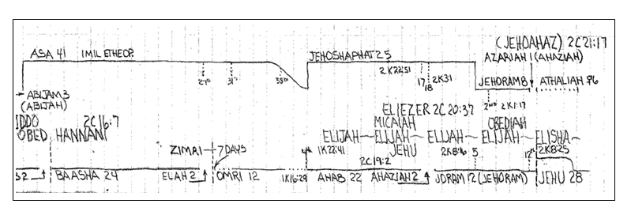
Purpose: to pronounce judgment on the Edomites who had responsibility and opportunity to assist the Jews during a time of need.
Idea: Nations that attempt to destroy Israel will be appropriately judged.
Development: The Edomites were descendants of Esau, Jacob’s brother. They had a familial responsibility to assist Israel. Instead they celebrated Israel’s trouble. The land of Edom is presently in Jordan and modern-day Petra is biblical Bozrah, the site of Christ’s return. In the Millennium Edom remains desolate and the descendants of Esau are destroyed. There is a lot of information in the Bible pertaining to Edom and the yet unfulfilled prophecies should not be ignored.
- Geographical security will not protect Edom, Obadiah 1-4.
- Not even a wise man will be left, Obadiah 5-9.
- For Edom’s eight atrocities they will be destroyed, Obadiah 9-14.
- The Tribulation will come upon all nations and the houses of Jacob and Joseph will possess the entire region of Edom, Obadiah 15-21.

Joel
Author: Joel, Joel 1:1
Date of writing: The date is uncertain; 835 B.C. is a conservative suggestion.
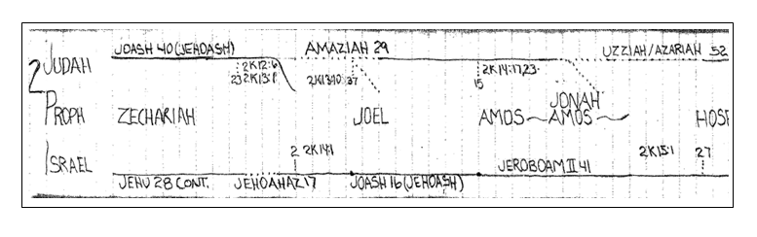
Purpose: to use the occasion of a locust invasion to teach about 3 additional invasions.
Idea: Multiple invasions are necessary before the Lord will dwell in Jerusalem.
Development:
- An Army of Locust, 1:1-20.
- An Army of Demons, 2:1-14.
2:1 “Blow the trumpet.”
  - Description of the Day, 2:1-2.
  - Description of the Army, 2:3-5.
  - Description of the Attack, 2:6-11.
  - Exhortation to repent, 2:12-14.
- The Northern Army, 2:15-3:8.
2:15 “Blow the trumpet.”
  - Exhortation to corporate, Jewish, prayer, 2:15-17.
  - Promise of protection, 2:18-20.
  - Promise of provision, 2:21-27.
  - Promise of Jewish revival, 2:28-29.
  - Promise of Gentile salvation, 2:30-32.
  - The powerless nations will be judged and treated as they treated Israel, 3:1-8.
- All the World’s Armies, 3:9-16.
  - The command for all the armies to come, 3:9-12.
  - The armies will be destroyed, 3:12-13.
  - The heavens and earth will participate in the Lord’s judgment of the armies and the protection of Israel, 3:14-16.
- The Lord’s presence in Zion will protect her forever, 3:17-21.

Key Passage Exegesis
- Joel 2:30-31 in connection with the northern invasion, Joel 2:20.
- Armageddon.

Jonah
Author: Jonah, Jonah 1:1.
Date of writing: 760 B.C.
Purpose: to demonstrate the grace of God upon the repentant Ninevites.
Idea: God is gracious to all who respond.
Development:
  - Jonah rebels against the Lord, Jonah 1:1-17.
  - Jonah reflects on punishment, Jonah 2:1-10.
  - Jonah preaches and the Ninevites believe, Jonah 3:1-10.
  - God teaches Jonah about His compassion for all, Jonah 4:1-11.
Key Passage Exegesis
- Our God is amazingly gracious, Jonah 4:2.

Amos
Author: Amos, Amos 1:1
Date of writing: 755 B.C.
Purpose: to preach against the syncretistic false worship established in the northern nation of Israel.
Idea: The sin of Israel will be judged, and following judgment will be restoration.
Development:
- The Prologue, Amos 1:1-2. The happy herdsman, Amos, declares that the Lord will roar from Zion.
- The Roar of Judgment, Amos 1:3-2:16.
  - Judgment against the nations, Amos 1:3-2:5.
  - Judgment against Israel (for injustice 6, oppression 7a, shameless immorality 7b, desecration 8, and scornful contempt of the Lord's benefits 9-12) will result in their destruction, Amos 2:6-16.
- Reasons for Judgment, Chapters 3-6.
  - The first message: Israel's false system will come to an end, Amos 3:1-15.
  - The second message: God's people should not rebel, because He is truly the real God. (Israel's women and worship services are rebellious (1-5) and since the increasingly sever discipline did not deter them (6-11), they will soon meet the real God (12-13), Amos 4:1-13.
  - The third message: the people are to seek the Lord who made the universe, Amos 5:1-17.
  - The First Woe: the Day of the Lord will be a time of devastating judgment upon the rebellious house of Israel, Amos 5:18–27.
  - The Second Woe: God judges everyone, especially the wealthy, famous leaders of Israel, Amos 6:1-14.
- The Results of Judgment in visions, Amos 7:1-9:10.
  - The averted vision of swarming locusts, Amos 7:1-3.
  - The averted vision of devouring fire, Amos 7:4-6.
  - The devastatingly accurate plumb-line vision requires Israel's desolation, Amos 7:7-17.
  - The prophet Amos stands his ground against Israel's finest opposition, Amos 7:10-17.
  - The vision of summer fruit symbolizes the ephemeral nature of the wicked whose bodies will cover the ground. The economic sins will bring massive earthquakes, darkness, mourning, and silence from God, and complete destruction of the false religious system. While the false system of Israel will also be destroyed, this chapter best describes the destruction of the false religious system Israel develops under the covenant with the Antichrist, Amos 8:1-14.
  - The vision of the avenging Lord striking the top of the pillars of the temple, Amos 9:1-8.
- The Restoration after Judgment. The godly Jews will be returned to their productive land where they will rule over all of their enemies and all the believing gentiles, Amos 9:9-15.

Key Passage Exegesis
- The role of prophets in God’s program, Amos 3:7.

Hosea
Author: Hosea, Hosea 1:1. Hosea prophesied to the northern nation of Israel.
Date of writing: 710 B.C.
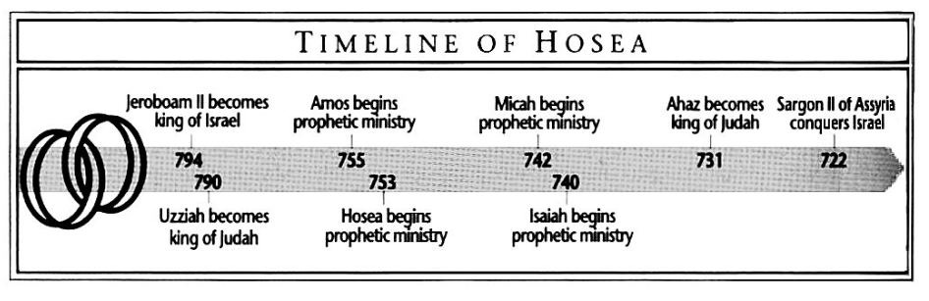
Purpose: to demonstrate to rebellious Israel God’s heart of love.
Idea: God’s love allows for restoration.
Development:
- The Marriage of Hosea: His Love for an Unfaithful Wife, Hosea 1-3.
  - Hosea’s Marriage, Hosea 1:2-2:1.
  - Hosea’s Divorce, Hosea 2:3-2:23.
  - Hosea’s Remarriage, Hosea 3:1-5.
- The Message of Hosea: God’s Love for Unfaithful People, Hosea 4-14.
  - Round One (Indictment), Hosea 4:1-6:3.
  - Round Two (Judgment), Hosea 6:4-11:11.
  - Round Three: (Restoration), Hosea 11:12-14:9.
Key Passage Exegesis
- The restoration of Israel, Hosea 3:1-5.
- Hosea is famous for his figures of speech, cf. Hosea 4:16.

Micah
Author: Micah, Micah 1:1. Micah prophesied to both the northern and southern kingdoms. He also saw the fall of Israel in 722.
Date of writing: 735-710 B.C.
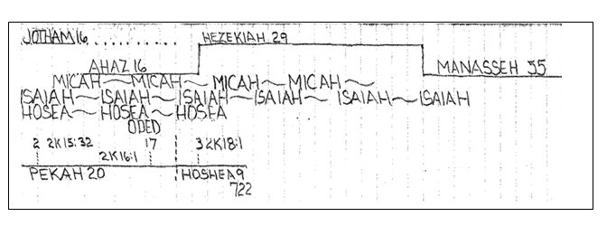
Purpose: to forcefully predict the coming judgement upon sin.
Idea: Although God would severely judge His people, they would be restored.
Development:
- Introduction, Micah 1:1.
- Summon to the people, Micah 1:2-3:13.
  - Judgment, Micah 1:2-2:11.
  - Hope, Micah 2:12-13.
- Summon to the leaders, Micah 3:1-5:15.
  - Judgment, Micah 3:1-12.
  - Hope, Micah 4:1-5:15.
- Summon to the mountains, Micah 6:1-7:20.
  - Judgment, Micah 6:1-16.
  - Hope, Micah 7:1-20.
Key Passage Exegesis
- The Millennial Kingdom, Micah 4:1-3.
- Bethlehem, Micah 5:2.

Nahum
Author: Nahum, Nahum 1:1.
Date of writing: about 660 B.C. He wrote about 100 years after Jonah and when Assyria was at its peak. Mosel is the modern city of Nineveh. Israel has been deported.
Purpose: to prophesy against Nineveh’s ultimate destruction.
Idea: The world-class city of Nineveh will be desolate.
Development:
- The Title, Nahum 1:1.
- The Certainty of God’s Judgment on Nineveh, Nahum 1:2–15.
  - God’s wrath to be extended to Nineveh and His goodness to His own, Nahum 1:2–8.
  - Nineveh’s plotting against the Lord to come to an end, Nahum 1:9–11.
  - Judah’s affliction to end because of Nineveh’s destruction, Nahum 1:12–15.
- The Description of God’s Judgment on Nineveh, Nahum 2:1-13.
  - The attack, Nahum 2:1–6.
  - The defeat and the plundering, Nahum 2:7–13.
- The Reasons for God’s Judgment on Nineveh, Nahum 3:1-19.
  - Her violence and deceit to result in shame, Nahum 3:1–7.
  - Her treatment of Thebes to result in her own defeat, Nahum 3:8–11.
  - Her defense efforts to be useless, Nahum 3:12-19.

Key Passage Exegesis
- Nineveh will be completely destroyed, Nahum 1:9-14.

Zephaniah
Author: Zephaniah, Zephaniah 1:1. Zephaniah was a descendant of Hezekiah, had access to the royal court, and saw a revival during his prophesying.
Date of writing: 630-625 B.C.
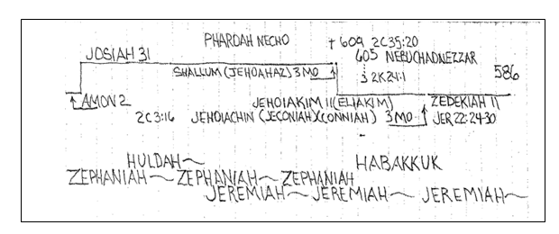
Purpose: to prophesy about the Day of the Lord and the Millennial reign of Christ.
Idea: The global judgement results in the remnants salvation with the Lord in their midst.

Development:
- Introduction, Zephaniah 1:1.
- The Day of the Lord – Judgment, Zephaniah 1:2-3:7.
  - Judgment on Judah and Jerusalem, Zephaniah 1:2-2:3.
  - Judgment on the Surrounding Nations, Zephaniah 2:4-15.
  - Judgment on Jerusalem, Zephaniah 3:1-7.
- The Day of the Lord – Blessing, Zephaniah 3:8-20.
Key Passage Exegesis
- Epitome of pride, Zephaniah 2:15.
- The return of the Remnant, Zephaniah 3:9-20.

Habakkuk
Author: Habakkuk, Habakkuk 1:1, 3:1
Date of writing: Near the beginning of the deportation of Judah, 607 B.C.
Purpose: to answer the question, “Why doesn’t God judge the wicked?”.
Idea: God manages the nations as He sees fit to the end that Christ will rule with those who walk by faith.

Development:
- Introduction, Habakkuk 1:1.
- The Prophet’s Problems: The Righteousness of God, Habakkuk 1:2-2:20.
  - First Problem: Israel’s Sin and God’s Silence, Habakkuk 1:2-11.
  - Second Problem: Babylon’s Cruelty and God’s Silence, Habakkuk 2:12-20.
- The Prophet’s Prayer: The Right Response to a Righteous God, Habakkuk 3:1-19.
Key Passage Exegesis
- The just shall live by his faith, Habakkuk 2:4.
- The second coming of Christ, Habakkuk 3:3-4.

Post-Exilic Prophets
Haggai
Author: Haggai, Haggai 1:1, 3, 12, 13, 2:1, 10, 13, 14, 20).
Date of writing: 520 B.C.
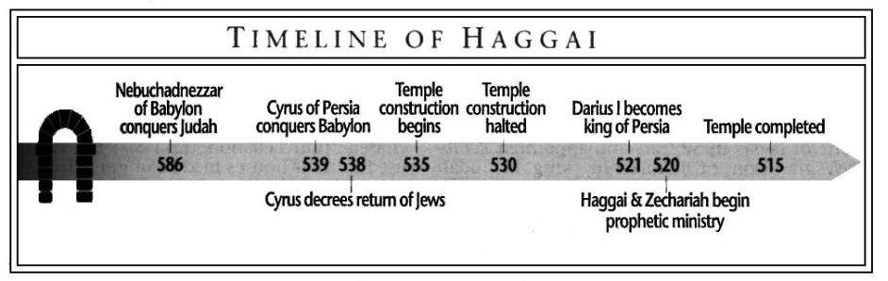
Purpose: to encourage the people returned to the land to build the temple.
Idea: One always has adequate resources to do God’s will.
Development:
- First Message: Neglecting the Temple, Haggai 1:1-15.
- Second Message: The Glory of the Temple, Haggai 2:1-9.
  - The Glory of the Present Temple, Haggai 2:1-5.
  - The Glory of the Future Temple, Haggai 2:6-9.
- Third Message: The Blessing of Rebuilding the Temple, Haggai 2:10-19.
- Fourth Message: The Kingdom is Coming, Haggai 2:20-23.
Key Passage Exegesis
- It all belongs to God, Haggai 2:8.

Zechariah
Author: Zechariah
Date of writing: 520 B.C., a contemporary with Haggai.
Purpose: to encourage the people to rebuild both the temple and the city.
Idea: Since Jerusalem will be the center of worship for the world (Zechariah 14:16), the people should follow the Lord and rebuild it.
Development:
- The Call to Repentance, Zechariah 1:1–6.
- The Visions of Zechariah, Zechariah 1:7–6:15.
- The Questions Concerning Fasts, Zechariah 7:1–8:23.
- The Oracles Concerning the Future, Zechariah 9:1–14:21.
  - The First Oracle, Zechariah 9:1–11:17.
    - The victories of Alexander the Great, Zechariah 9:1–8.
    - The comings of the King, Zechariah 9:9–10.
    - The victories of the Maccabees, Zechariah 9:11–17.
    - The blessings from Messiah, Zechariah 10:1–12.
    - The rejection of the Shepherd, Zechariah 11:1–17.
  - The Second Oracle, Zechariah 12:1–14:21.
    - The Lord’s care for Jerusalem, Zechariah 12:1–14.
    - The Lord’s cleansing of Jerusalem, Zechariah 13:1–9.
    - The Lord’s second coming to Jerusalem, Zechariah 14:1–21.

Key Passage Exegesis
- Armageddon and the Second Coming of Christ, Zechariah 14:1-21.

Malachi
Author: Malachi, Malachi 1:1
Date of writing: 430 B.C. He probably wrote about 100 years after Haggai and Zechariah.
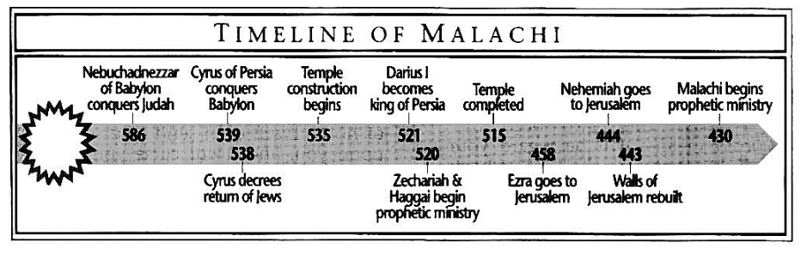
Purpose: to stir up the people to a renewed commitment to the Lord.
Idea: Indifference is a sin God judges.
Development:
- God’s love and disappointment with His people, Malachi 1:1-14.
- God’s disappointment with the priests, Malachi 2:1-17.
  - The priests have corrupted the Law, Malachi 2:1-9.
  - The priests preside at mixed marriages, Malachi 2:10-12.
  - The priests permit divorce, Malachi 2:13-16.
  - The priests are tired of their interaction with the Lord, Malachi 2:17.
- The Jewish world will be prepared for the Remnant, Malachi 3:1-18.
- Before the Return of Christ there will be judgment and Elijah, Malachi 4:1-6.
Key Passage Exegesis
- The closing verses of the Old Testament, Malachi 4:5-6.

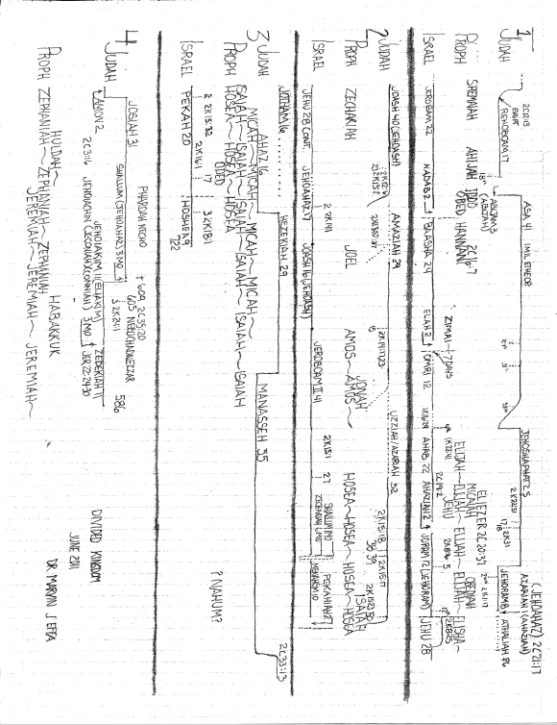

Ryrie, C. C. (1995). Ryrie study Bible: New American Standard Bible, 1995 update (Expanded ed., p. 625). Chicago: Moody Press.
G. Michael Cocoris, 2016 Euclid #20, Santa Monica, CA 90405, The Bible: Book by Book, 2000, internet paper.
Johnson, E. E. (1985). Nahum. In J. F. Walvoord & R. B. Zuck (Eds.), The Bible Knowledge Commentary: An Exposition of the Scriptures (Vol. 1, pp. 1496–1497). Wheaton, IL: Victor Books.
G. Michael Cocoris, 2016 Euclid #20, Santa Monica, CA 90405, The Bible: Book by Book, 2000, internet paper.
Ryrie, C. C. (1995). Ryrie study Bible: New American Standard Bible, 1995 update (Expanded ed., p. 1460). Chicago: Moody Press.

